Grade 1
Tic Tac Toe Game

Description: | Students will:  Use the clean edge paint tools to draw a grid and game pieces.  Analyze the game to determine the total number of game pieces needed.  Make a pictograph of win/loses.  Type a title for the project.
Project  View | 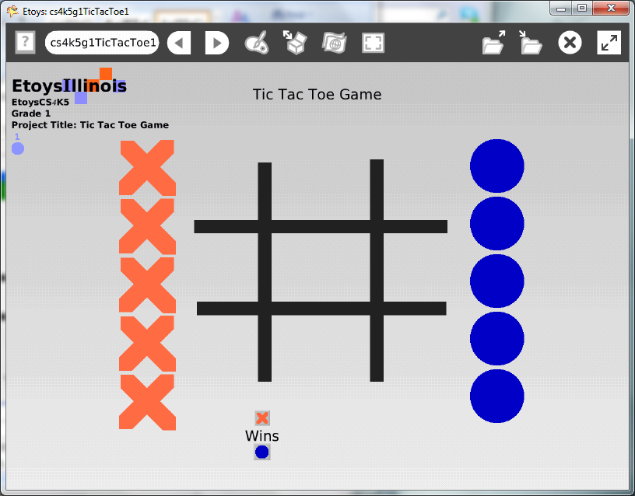
Subject: | Math
Etoys Quick Guides | Click the question mark in Etoys to open the set of interactive tutorials for basic tools and techniques.
Vocabulary: | Patterns, shapes, smallest, biggest, size, scale, top, bottom, left, right, similar, same, almost, different, increase, decrease, rules, graph, chart
Lesson 1:  Paint Tools: Ellipse Tool | Introduce the clean edge tools and give students time to experiment with all five tools and all six brush sizes.  Give students practice combining brush sizes, clean edge tools, and colors, and locations. For example ask students to use the smallest brush, the ellipse tool, with six different shades of their favorite color and draw six ellipses as close to the top edge as they can make them.  Even though they are all following the same set of directions, their screens will have similarities and differences. Ask students to look at other screens in the lab and talk about what they see and if they have ideas to add to the directions to increase and/or decrease similarities.  Give them time to notice differences beyond the variety of colors, to also notice such details such as, how close to the top of the screen the shapes are, how close to each other they are, how evenly they are spaced across the screen.  Give students time to take turns with a neighbor giving and receiving sets of directions.
Lesson 2:  Paint Tools: Straight Line Tool  Paint Tools: Size, Color, Copy  Navigator Bar: Keep Find Projects | Playing Tic Tac Toe with the paint tools. Give students time to draw a grid and play Tic Tac Toe with a neighbor. They will use the Clear button to erase each game as they finish playing.  Ask them to count how many turns in a game. Ask them how many X’s and O’s will be enough tokens to play the game. Discuss their answers.  Make the game grid with one paint palette and click keep.  Paint one X with a new paint palette and keep it. Use the green halo handle to make enough copies.  Paint one O with a new paint palette and keep it. Use the green halo handle to make enough copies.  Give students time to put all the pieces of the game on their screen, deciding how close to the top, middle, sides the grid and pieces will be.  Keep the project. Call it nameTicTac, for example kateTicTac.
Standards: | Common Core Standards  Mathematics: 1.MD.4  Language Arts: SL.2,3  Bloom’s Taxonomy/Cognitive Domain:  Knowledge: describes, selects  Application: demonstrates, produces, uses  Analysis: analyzes  Evaluation: compares, describes  NETS  1. a, b, c, d  2. b  3. a, b, d  4. a, b, c  6. b
Resources: | Etoys Help Quick Guides: always available in Etoys. Open Etoys and click the question mark to open a set of interactive tutorials of basic tools and techniques.  www.etoysillinois.org projects, lesson plans, software download  www.mste.Illinois.org more math, science, and technology resources  www.corestandards.org Common Core Standards  www.squeakland.org software and Etoys projects  www.nctm.org Standards and Focal Points for each grade level
kh January 2011

